**Cloud Computing/Virtualization**

Instructor: Mousa Ayyash

Group Members :

* Ashwan Kumar Reddy Avula
* Anvesh Gorrepati
* Akifullah Khan
* Anand Kumar Reddy

Final Project Part 1

**Project Overview:**

Viva Health is an Indonesia-based integrated health service provider serving over 5 million customers across more than 142 pharmacies in West Java, Central Java, Yogyakarta, East Java and Bali. Aside from medicine and healthcare products, 50 percent of Viva Health’s pharmacies are also integrated with doctor consultation services.

To address a growing demand for healthcare e-commerce and teleconsultation services in Indonesia, Viva Health sought to modernize its IT infrastructure. In 2019, Viva Health decided to move its SAP Business Suite on HANA to the cloud. Previously, it ran SAP on an on-premises infrastructure, making the provisioning of new servers a costly process. Scalability was also an issue. Viva Health experienced frequent outages and hardware failures, especially during periods of heavy workloads. Hardware replacements often took up to 2 days to arrive and a further 2 days to deploy. This impacted Viva Health as its production business had to operate around the clock and could not afford downtimes.

With help from Cloud Comrade, an Amazon Web Services (AWS) SAP Competency Partner, the company successfully migrated to the AWS Cloud within 4 months, achieving near-zero downtime and laying the groundwork for its digital expansion into e-commerce and teleconsultation.

SAP on AWS:

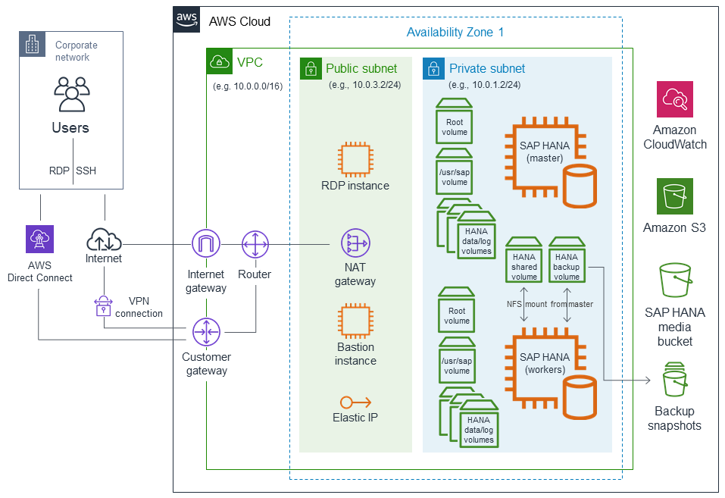

Migrating SAP HANA from Other Platforms to AWS


            Backup and restore
          

Required AWS Services:

1. AWS Direct Connect
2. VPN Connect
3. VPC
4. EC2
5. S3
6. Amazon Cloudwatch

**SAP migration to the cloud**

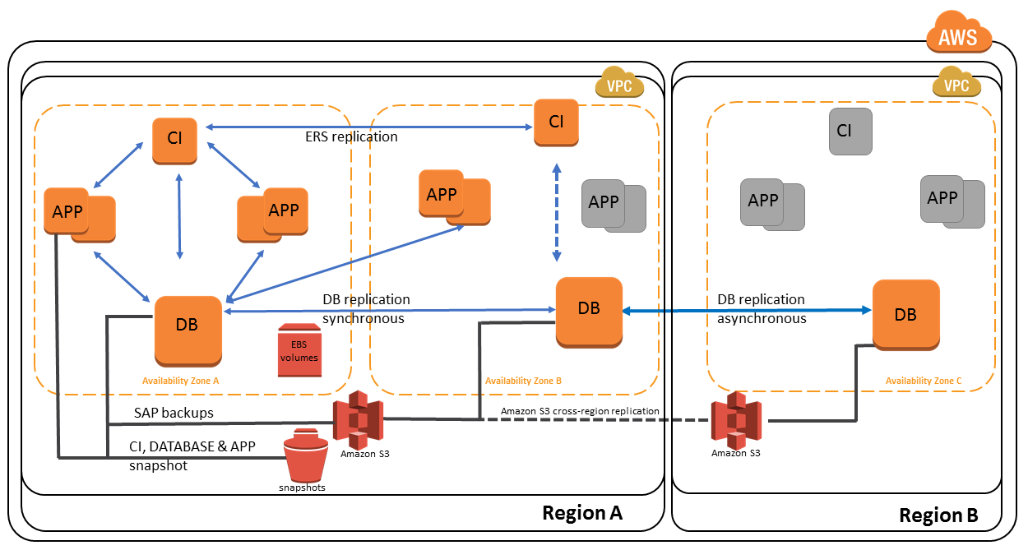

SAP migration to the cloud happens when companies move their SAP applications, data and technology to managed cloud services. As the migration is from one platform to a totally different platform, there are a number of things to be taken care of.

SAP migrations are mission critical, hence they should be done within the specified time with the minimum risk and maximum flexibility. This brings in great financial gains because there is a huge decrease in operating expenses and a reduction in the usage of infrastructure. However, it is very important to carefully plan the migration or else you will end up with more costs, rather than a good return on investment.

**The process of SAP migration**

**1. Checking compatibility**

You need to check the compatibility of your SAP applications, databases and operating systems with that of the cloud vendors. Ask your vendor whether they can support your upgrades as well.

You can also analyze the technical, language standards and governance of the potential cloud vendor to your company’s internal standards, and see whether that matches as well. Check whether the components match, and if they have a good team of IT specialists with integration skills to analyze the risks. And the vendor should also have the expertise to remove issues and ensure data safety 24/7.

**2. The size of storage is pay as you go**

Cloud vendors give you the absolute freedom to choose your storage size. However, you don’t have to go too deep into this because you can always upgrade or downgrade as the requirement escalates or scales down. But this is a step in migration, and would give you an idea of how far you want your business to grow over a period of time, and when you need to purchase more storage from the vendor. So you apply the average utilization policy, and just get the exact size you need now, and then grow whenever necessary.

**3. Choosing the right location**

Cloud servers are located everywhere in the world, and you can choose from anywhere. However, WAN or Wide Area Network costs will be incurred, so it would be advisable to choose a location closer to home.

The law states that cloud service providers must be transparent about the location of their data center servers, but if you are not able to find this easily, you can ask them directly. After all, your applications have to be in a safe place, and close to where your users are. Choosing the servers and hosting the applications closer to the geographical location of your users would enable them to have a great experience with your product.

**4. Choosing the service**

Another step to remember would be the type of service for your SAP item. There are three levels to choose from:

Entry-level set (ES) - The first level is more suitable for disengaged ventures. This option is for minimal SAP and database services mainly intended for standalone SAP blueprints, training systems, demos and so on. As it is entry-level, most customers test new systems, create SAP demos and conduct training programs. It is also meant for small isolated work items.

Development service - Development service or DS is all about SAP and database support for development and quality assurance, right from the start of development until it goes live. The cloud vendor does this to support customers through the process of implementation, entire transition and then onto full service.

Full service - Just as the name denotes, the vendor provides complete service right from the beginning till the end. There is full scope of SAP and database support. You can choose this kind of service from the cloud vendor when you need more support for more than one system landscape like in ES and DS. Full Service can be expanded to include language installations, SAP user administration, database refresh and so on.

**5. Planning and budgeting**

Planning and budgeting is the next step in migration. The better your plan, the easier the cloud migration process would be. Though experts advise you to compare vendor costs, it cannot paint the entire picture because it is mostly like comparing apples and oranges. You must also consider the testing costs, and that would add up.

However, the cost of migration has always been a major consideration when moving to managed services. But several key IT players prefer predictability of costs rather than reduced costs. And that is the benefit of moving to cloud services. It is a matter of knowing how much you are spending, and the value it is generating for the business. With predictability of costs a preferred choice, it assures them that they are investing in the right places.

**6. Testing**

If your database or technology runs on an OS that isn’t on the cloud, then you will have to change those, and test them again. This could take up a lot of time, hence an important part in the migration process. On the other hand, if your SAP project is just beginning, you can have a local implementation on the cloud. This process would also take some time, so keep that in mind.

**Advantages of moving to the cloud**

High-performance, quick deployment - If you need fast application implementation and deployment, cloud is the best choice.

Impressive cost management - Your costs can be controlled since it’s a ‘pay as you use’ scenario.

Agility, flexibility and hassle-free upgrades - The cloud offers a highly flexible hosting solution, and strategies for migration would be charted by the vendor, helping your business grow.

Scale-up and down as per seasonal requirements - Enjoy automatic scaling or resources as per demand. Once again, you need to pay only for what resources you use.

Move from large CapEx (Capital Expenditure) to stable OpEx (Operating Expenditure) - Accounting costs will be more stable, and this could be beneficial during tax and accounting.

Security - SAP can be secure when it is on-premises. But with built-in access control, extensive standard encryption, and support, reputed cloud vendors can also provide the same level of security.

**Conclusion**

Migrating SAP applications to the cloud would definitely be financially rewarding, infrastructure-wise beneficial, with elevated levels of flexibility for desired functions, combined with low operating costs. However, you need to have a good plan in hand and application readiness is mandatory.